Final Project Report

<< Web-based Fitness Management System >>



Project Supervisor
<< Qaiser Shabbir >>

Submitted By

<< S25PROJECT73EE2 >> <<VU ID: BC200201057 >>

Software Projects & Research Section,
Department of Computer Sciences,
Virtual University of Pakistan


CERTIFICATE

This is to certify that << Fatima Pir >> (<<VU ID: BC200201057>>), have worked on and completed their Software Project at Software & Research Projects Section, Department of Computer Sciences, Virtual University of Pakistan in partial fulfillment of the requirement for the degree of BS in Computer Sciences under my guidance and supervision.

In our opinion, it is satisfactory and up to the mark and therefore fulfills the requirements of BS in Computer Sciences.

Supervisor / Internal Examiner

<< Qaiser Shabbir >>
Supervisor,
Software Projects & Research Section,
Department of Computer Sciences
Virtual University of Pakistan

___________________
(Signature)

External Examiner/Subject Specialist
<<External Supervisor Name>>

___________________
(Signature)

Accepted By:

_____________
(For office use)

EXORDIUM

In the name of Allah, the Compassionate, the Merciful.

Praise be to Allah, Lord of Creation,
The Compassionate, the Merciful,
King of Judgment-day!

You alone we worship, and to You alone we pray for help,
Guide us to the straight path

The path of those who You have favored,

Not of those who have incurred Your wrath,
Nor of those who have gone astray.

DEDICATION

In The Name Of Allah, The Most Beneficent, The Most Merciful. I Am Unable To Complete My Work Without The Support Of My Kind Supervisor. I Am Sincerely Thanks To My Parents To Encourage Me And Thanks To My Teacher Who Support Me And Guide Me Throughout The Project Activities, Thanks A Lot To Everyone Who Give Me Good Wishes All The Time. Allah Bless Him All Time And This Project Is Dedicated To My Father, Who Taught Me That The Best Kind Of Knowledge to Have Is That Which Is Learned For Its Own Sake. It Is Also Dedicated To My Mother, Who Taught Me That Even The Largest Task Can Be Accomplished If It Is Done One Step At A Time.

You Have Successfully Made Me. The Person I Am Becoming
You Will Always Be Remembered.

ACKNOWLEDGEMENT

I am highly grateful to Allah for His blessing that continue to flow into my life, and because of You, I made this through against all odds.
With a great pleasure I would like to acknowledge the support, assistances and contribution made by individuals from the beginning of the Project, providing me access, data and information, to the writing process until the completion of this project.
First of all, I want to give thanks to our project supervisors
Qaiser Shabbir for the access and assistance in order to make my project possible.
Second I would like to thank all my friends and colleagues, thank you all for the assistance and constructive discussions we had during the whole project construction.
PREFACE

For preparing of the project report, I have closely studied the application needs, outcomes and data requirements that will be used successfully to protect any entrance breaches.

I would have to design and implement four different interfaces, one for the Homepage/landing page, one for the Admin, one for the driver and one for the passenger. Admin will be managing both driver and passengers’ account. Our Application is intercity based, so we will be covering Parent Teacher Communication and management system services only. When any user will land on our website’s home page, a listening of travelling event with respect to date time and seats availability will be exhibited to the user or user can also search for travelling events by entering his departure city, arrival city and date.

This project started with to test phases I and test phases II which have given me the ability to understand the concept of programming and move me forward smoothly.

I am very thankful to my supervisors Mir Salam Khan who have helped me to complete this project and I really appreciate all his efforts and support.

By achieving my task, I studied and research all related articles, books and lectures of this application.

TABLE OF CONTENTS

CHAPTER 1 9
GATHERING & ANALYZING INFO 9
1.1. Introduction 10
1.2. Purpose of Project 10
1.3. Scope of Project 10
1.4. Definition, Acronyms and Abbreviation 11
1.5. Project Requirements 11
1.5.1. Functional Requirement 11
1.5.2. Non-Functional Requirement 12
1.6. Use Cases and Usage Scenarios: 13
1.6.1. Use case Diagrams: 13
1.6.2. Usage Scenarios: 14
CHAPTER 2 20
PLANNING THE PROJECT 20
1.7. Development Methodology 21
1.7.1. Chosen Methodology 23
1.7.2. Reasons for chosen Methodology and VU process model. 24
1.7.3. Work Plan (Gantt Chart) 26
CHAPTER 3 27
Design Documents 27
2.1. Introduction of Software Design Document (SDD) 28
2.2. Purpose of Design Document 30
2.3. Scope of Design Document 30
2.4. Definitions, Acronyms and Abbreviations 30
2.5. Architecture Representation (Architecture Diagram) 31
2.6. Entity Relationship Diagram 32
2.7. Dynamic Model: Sequence Diagrams 33
2.8. Object Model / Logical Model: Class Diagram. 37
2.9. Database Model (Database Diagram) 38
2.10. Graphical User Interface 39

CHAPTER 1
Gathering & Analyzing Info

  - Introduction
This design document outlines the architecture, components, and functional flow of the Web-based Fitness Management System. It includes detailed descriptions of system entities (Admin, Member, Trainer), database design, user interface layouts, functional and non-functional requirements, and overall interaction between modules. The document also presents data flow diagrams, entity-relationship diagrams, and system architecture to visualize the inner workings of the system.
  - Purpose of Project

The purpose of this phase in a software development project is to transform the collected requirements into a blueprint for developers and stakeholders. It acts as a bridge between the planning and implementation phases by offering a clear technical understanding of the system’s structure and behavior. The benefits of this phase include reducing ambiguity, ensuring consistency, minimizing risks, and enabling smooth collaboration among team members. A well-prepared design document ensures that development aligns with user needs and system goals, ultimately resulting in a high-quality and maintainable product.
  - Scope of Project

The Web-based Fitness Management System aims to provide a comprehensive digital platform for managing gym and fitness center operations. This system will serve as a centralized platform for three main users: Admin, Trainer, and Member. Admins will manage member and trainer records, track subscriptions, and oversee daily operations. Members will be able to register, choose trainers, purchase or renew memberships, and track their fitness progress online. Trainers will manage workout and diet plans and mark member attendance. The system will integrate secure payment gateways, automated notifications, and data analytics features to enhance communication and performance tracking. It will be accessible across devices, reducing manual workloads and improving operational efficiency for gyms and fitness centers.

  - Definition, Acronyms and Abbreviation
This section lists key terms used in the Web-based Fitness Management System. It includes definitions of major system entities, technical concepts, and commonly used acronyms. These help ensure clarity, consistency, and shared understanding among developers, stakeholders, and users throughout the design and development phases of the project.

  - Project Requirements
There are two basic requirement of the system, Functional and non-functional requirements are given below:-
    - Functional Requirement
Admin Functionalities:
Login/logout using credentials.
Add, modify, or delete member and trainer records.
Manage trainer profiles, availability, and shift schedules.
Member Functionalities:
Register, log in, and purchase or renew membership plans.
Log fitness progress and track historical data.
Book appointments with trainers and classes.
Review and rate trainers.
Secure online payment integration.
Trainer Functionalities:
Login/logout using credentials.
Create, assign, and modify workout and diet plans.
Mark attendance of members.
View and manage appointment schedules.
Common Features:
Automated notifications via email/SMS for updates.
User-friendly dashboards for each role
Non-Functional Requirement
Security: Secure login, encrypted data storage, and compliance with web security standards.
Performance: Efficient handling of multiple users without lag.
Scalability: Easily adaptable to growing users and expanding fitness centers.
Usability: Clean and intuitive interface for easy navigation.
Availability: High system uptime and consistent availability.
Compatibility: Support for all major browsers and mobile devices.
Maintainability: Easy updates with minimal disruptions.
Backup & Recovery: Scheduled backups and quick data recovery options
1.6.2. Usage Scenarios:

Usage Scenario 1: Admin Login
Field | Details
Use Case Title | Admin Login
Use Case ID | UC01
Actions | Admin enters credentials and logs into the system.
Description | Allows the admin to securely access the system features.
Alternative Paths | Incorrect password entered → Show error message.
Pre-Conditions | Admin must be registered with valid credentials.
Post-Conditions | Admin is directed to the admin dashboard.
Author | FATIMA PIR (BC200201057)
Exceptions | Server down, invalid credentials, browser compatibility issues.

Usage Scenario 2: Add New Member
Field | Details
Use Case Title | Add New Member
Use Case ID | UC02
Actions | Admin inputs member data and saves it.
Description | Admin registers a new member into the system.
Alternative Paths | Form not completely filled → Prompt error message.
Pre-Conditions | Admin must be logged in.
Post-Conditions | Member data is saved, member receives registration confirmation.
Author | FATIMA PIR (BC200201057)
Exceptions | Duplicate entry, network interruption, database error.

Usage Scenario 3: Member Login
Field | Details
Use Case Title | Member Login
Use Case ID | UC03
Actions | Member enters email and password to log in.
Description | Allows member to access personal dashboard and services.
Alternative Paths | Wrong credentials → Error message. Forgot password → Reset option.
Pre-Conditions | Member must be registered.
Post-Conditions | Member accesses dashboard.
Author | FATIMA PIR (BC200201057)
Exceptions | Account locked, internet issues.

Usage Scenario 4: Purchase Membership
Field | Details
Use Case Title | Purchase Membership
Use Case ID | UC04
Actions | Member selects and pays for a membership plan.
Description | Enables a member to purchase a membership plan online.
Alternative Paths | Payment fails → Retry payment. Cancel payment → Redirect to dashboard.
Pre-Conditions | Member must be logged in.
Post-Conditions | Membership activated, receipt generated.
Author | FATIMA PIR (BC200201057)
Exceptions | Payment gateway error, invalid card.

Usage Scenario 5: Book Appointment with Trainer
Field | Details
Use Case Title | Book Appointment with Trainer
Use Case ID | UC05
Actions | Member chooses trainer and time slot.
Description | Member books a one-on-one session or fitness class.
Alternative Paths | Slot not available → Show next available slot.
Pre-Conditions | Member must be logged in, trainer must be available.
Post-Conditions | Appointment confirmation sent.
Author | FATIMA PIR (BC200201057)
Exceptions | Double booking, trainer unavailability at runtime.

Usage Scenario 6: Trainer Login
Field | Details
Use Case Title | Trainer Login
Use Case ID | UC06
Actions | Trainer enters username and password.
Description | Grants trainers access to their dashboard to manage plans and clients.
Alternative Paths | Wrong credentials → Show error message.
Pre-Conditions | Trainer must be registered.
Post-Conditions | Trainer accesses their dashboard.
Author | FATIMA PIR (BC200201057)
Exceptions | Credential mismatch, inactive account.

Usage Scenario 7: Create Workout Plan
Field | Details
Use Case Title | Create Workout Plan
Use Case ID | UC07
Actions | Trainer inputs exercises, sets, reps for client.
Description | Trainer creates a personalized workout plan for members.
Alternative Paths | Use pre-made templates instead of creating from scratch.
Pre-Conditions | Trainer must be logged in.
Post-Conditions | Plan is saved and linked to member profile.
Author | FATIMA PIR (BC200201057)
Exceptions | Invalid form data, database write error.

Usage Scenario 8: Member Fitness Progress Tracking
Field | Details
Use Case Title | Member Fitness Progress Tracking
Use Case ID | UC08
Actions | Member logs progress metrics (weight, reps, sessions).
Description | Members track and visualize fitness progress over time.
Alternative Paths | Auto-track based on trainer updates or wearable sync.
Pre-Conditions | Member must be logged in.
Post-Conditions | Progress data is updated and stored.
Author | FATIMA PIR (BC200201057)
Exceptions | Input error, device sync failure.

Usage Scenario 9: Trainer Marks Attendance
Field | Details
Use Case Title | Trainer Marks Attendance
Use Case ID | UC09
Actions | Trainer selects members and marks them present or absent.
Description | Helps track attendance history for billing and progress.
Alternative Paths | Admin marks attendance in trainer's absence.
Pre-Conditions | Trainer must be logged in.
Post-Conditions | Attendance data is stored.
Author | FATIMA PIR (BC200201057)
Exceptions | Member not in list, system crash.

Usage Scenario 10: Trainer Provides Diet Plan
Field | Details
Use Case Title | Trainer Provides Diet Plan
Use Case ID | UC10
Actions | Trainer inputs meal plan and assigns to member.
Description | Offers personalized nutritional guidance for members.
Alternative Paths | Upload document instead of text input.
Pre-Conditions | Trainer must be logged in, member must be assigned.
Post-Conditions | Diet plan saved and visible to the member.
Author | FATIMA PIR (BC200201057)
Exceptions | Validation failure, member unassigned.
Use Case Diagram(s):

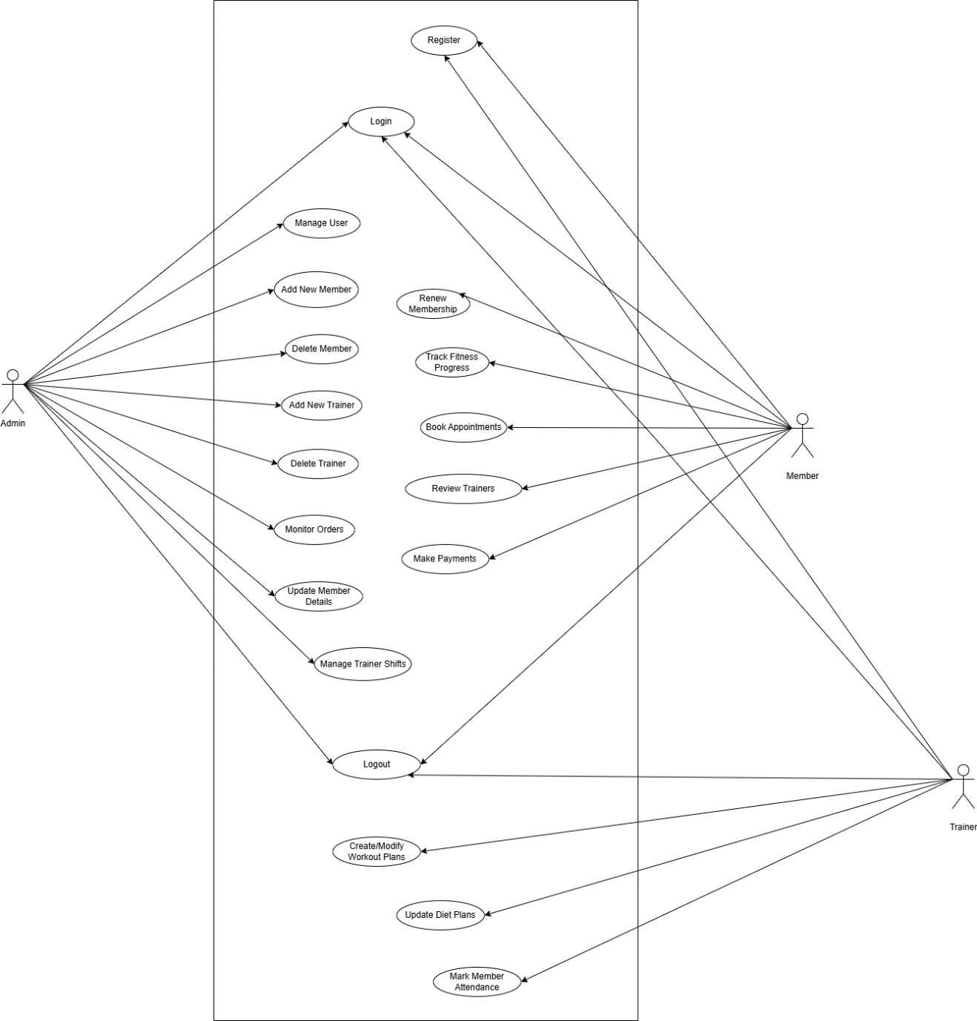

CHAPTER 2
Designing the Project

  - Development Methodology

Adopted Methodology
A software development methodology in software engineering is s framework that is used to structure, plan and control the process of developing an information system. Here we briefly about two of them which are commonly used.
- Waterfall Model:

- In Waterfall Model Requirements are defined in detail and will be considered as system specification.
- It suggests a systematic, sequential approach to software development model is analysis, design, coding, testing and maintenance.
- Waterfall Model has major time and cost related consequences.
- In waterfall Model maintenance task mush easier.

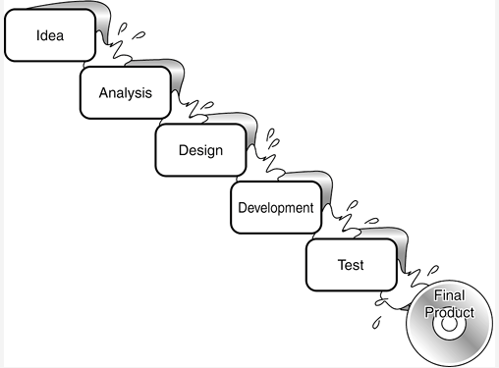

- Spiral Method:

- Spiral Model is Waterfall model plus Risk analysis.
- Each stage in spiral model is preceded by identification of alternatives and risk analysis and is then followed by evaluation and planning for the next phase.
- If risks cannot be resolved, project is immediately terminated.
- Project estimates in terms of schedule, cost etc. become more and more realistic as the project moves forward and loops in spiral get completed.
- Risk management is one of the in-built features of the model, which makes it extra attractive as compared to other models.

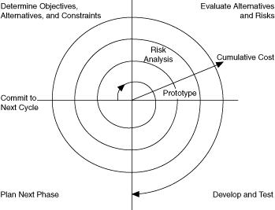
Adopted Methodology:

We adopt the combination of Spiral Model and Waterfall model. The main idea of this model is to avert risk as there is always an element of risk in development of software. In its simplified form, the Spiral model is waterfall model plus risk analysis. In this case each stage is preceded by identification of alternative and risk analysis and is then followed by evaluation and planning for the next phase.

Diagram is as under:
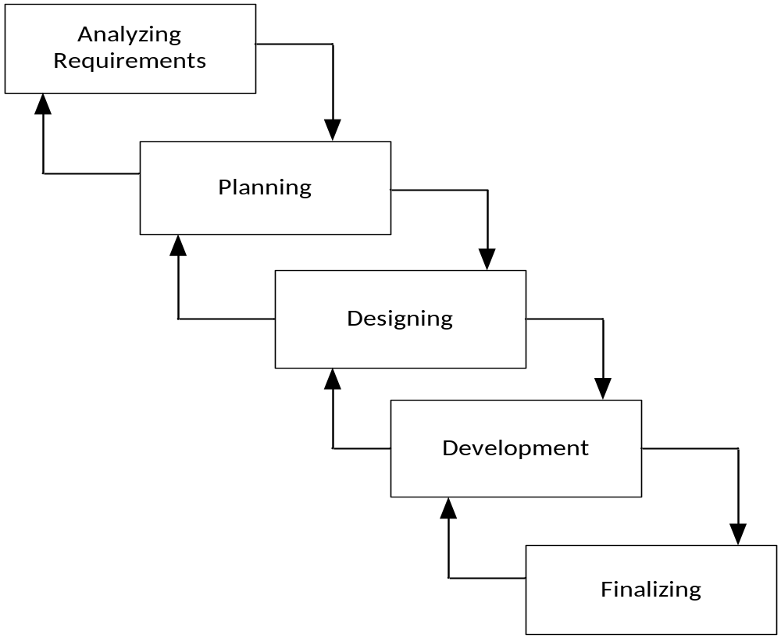
Reason for choosing the Methodology:
As we know that ever model have advantages and also disadvantages in accordance with the project requirements. We should choose the right type of the Model to implement based on the scope of the software project. This depends on a number of factors, some of which are the scope of the project, project budget, environment, available resources. But after studying the requirements of the project we choose VU process model which is a combination of waterfall and spiral models.

Following are the reasons for choosing this Methodology:
- The Spiral Model or the Spiral Development Model combines the best of the both top down and bottom up approaches and is specifically risk-driven. In essence the Spiral Model is a combination of the classic Waterfall Model and Risk Analysis.

- The Spiral Model provides a rapid development and at the same time, incremental versions of the software application.

- The combination of Waterfall and Spiral Model provides an orderly sequence of development steps and helps ensure the adequacy of documentation and design reviews to ensure the quality, reliability and maintainability of the developed software.

- Combination of Waterfall and Spiral models allows for feedback and creativity.

- In Spiral model, the project life cycle is divided into phases, and each phase is executed in all of the iteration of the Spiral Model.

- Unlike the waterfall model, where milestones are reached in a very linear manner, and you are not allowed to backtrack, the VU process model uses the spiral model’s ability to perform iterations when needed.
    - Work Plan (Gantt Chart)

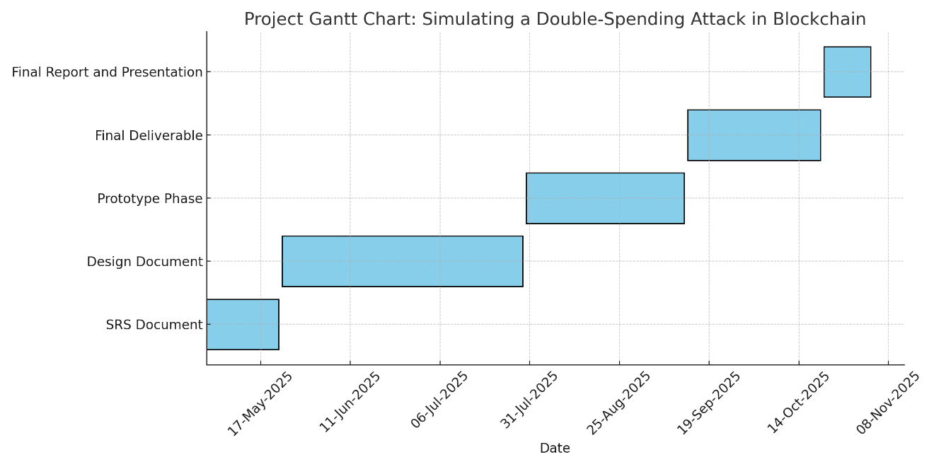

CHAPTER 3
Development

  - Introduction of Software Design Document (SDD)

Software Design Document (SDD) is the bridge between the requirement gathering and the final product. The detailed study of different operation that is performed by a system and the relationship between them within or outside of the system is called Analysis of a system or the given project.
Software Design Document (SDD) is a document to provide documentation which will be used to aid in software development by providing the details for how the software should be built. Within the software design document is narrative and graphical documentation of the software design for the project including use case models, sequence diagrams, collaboration models, object behavior models, and other supporting requirement information. In Software Design Document (SDD) we give a pictorial view to SRS by which we well understand the requirements and total project scope. In this software design document, we will look at the following functions.
The purpose of the Software Design Document (SDD) is to provide a description of the design of a system fully enough to allow for software development to proceed with an understanding of what is to be built and how it is expected to build. The Software Design Document (SDD) provides information necessary to provide a description of the details for the software and system to be built.

- Entity Relationship Diagram (ERD)
Diagrams created using this ER-modeling method are called Entity-Relationship Diagrams or ER diagrams or ERDs. This is a graphical representation of entities and their relationship to each other and An Entity Relationship Diagram (ERD) is a visual representation of different entities within a system and how they relate to each other. is a graphical representation of an information system that depicts the relationships among people, objects, places, concepts or events within that system.

- Sequence Diagrams
Sequence diagrams describe interactions among classes in terms of an exchange of messages over time. They're also called event diagrams. A sequence diagram is a good way to visualize and validate various runtime scenarios. These can help to predict how a system will behave and to discover responsibilities a class may need to have in the process of modeling a new system Sequence Diagrams is an “interaction diagram” that models a single scenario executing in a system. We can say that this type of diagram is the mirror of the requirement and also the design of the product.

- Architecture Design Diagram
Architecture Design Diagram is the high-level structure of an application system. It's the process of defining a structured solution that meets all of the technical and operational requirements, while optimizing common quality attributes such as performance, security, and manageability. This describes the layer architecture model for the product and is concerned with understanding how a system should be organized and designing the overall structure of that system.

- Class Diagram
Class Diagram gives the static view of an application. This diagram shows the classes their attributes and relationship between them and a class diagram in the Unified Modeling Language (UML) is a type of static structure diagram that describes the structure of a system by showing the system's classes, their attributes, operations (or methods), and the relationships among objects. A class diagram can refer to another class. A class can have its objects or may inherit from other classes.

- Database Design
Database Design is a collection of processes that facilitate the designing, development, implementation, and maintenance of enterprise data management systems. The main objectives of database designing are to produce logical and physical designs models of the proposed database system. Database design basically the real structure behind the system it logically connects the system.

- GUIs/interfaces Design
The user interface is the front-end application view to which user interacts in order to use the software. User can manipulate and control the software as well as hardware by means of the user interface. This shows the main feathers of the products like login page, register page, etc. GUI can be a combination of both hardware and software. Using GUI, The user interprets the software.

- Test Cases
A test case is a document, which has a set of test data, preconditions, expected results and, post conditions, developed for a particular test scenario in order to verify compliance against a specific requirement. A test case is a set of conditions or variables under which a tester will determine whether a system under test satisfies requirements or works correctly. It is the sequence of steps by which we check the system.

  - Purpose of Design Document
The purpose of the Software Design Document (SDD) is to provide a description of the design of a system fully enough to allow for software development to proceed with an understanding of what is to be built and how it is expected to build. The Software Design Document (SDD) provides information necessary to provide a description of the details for the software and system to be built. Software Design Document (SDD) is a document to provide documentation which will be used to aid in software development by providing the details for how the software should be built. Within the software design document is narrative and graphical documentation of the software design for the project including use case models, sequence diagrams, collaboration models, object behavior models, and other supporting requirement information

  - Scope of Design Document
Software Design Document (SDD) is a document to provide documentation which will be used to aid in software development by providing the details for how the software should be built. Within the software design document is narrative and graphical documentation of the software design for the project including use case models, sequence diagrams, collaboration models, object behavior models, and other supporting requirement information. In Software Design Document (SDD) we give a pictorial view to SRS by which we well understand the requirements and total project scope. In this software design document, we will look at the following functions. In Software Design Document (SDD) we give a pictorial view to SRS by which we well understand the requirements and total project scope. In this software design document, we will look at the following functions.

  - Definitions, Acronyms and Abbreviations
This document is called Software Design Document and sometime we write and read the abbreviation of these documents is (SDD).
  - Architecture Representation (Architecture Diagram)

Presentation Layer
Application Layer
Database Layer
Database

  - Entity Relationship Diagram

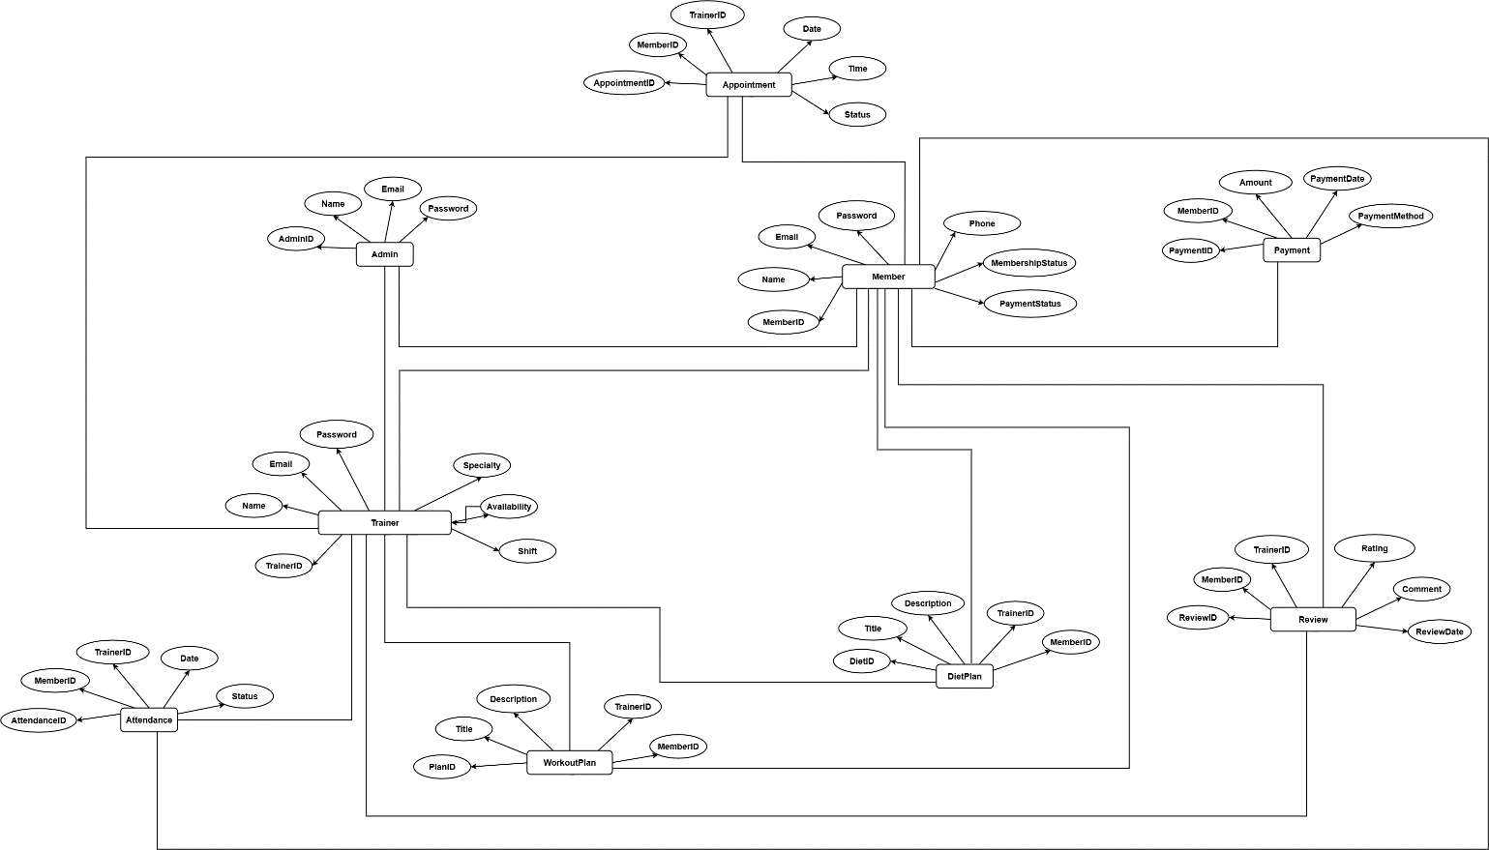

  - Dynamic Model: Sequence Diagrams

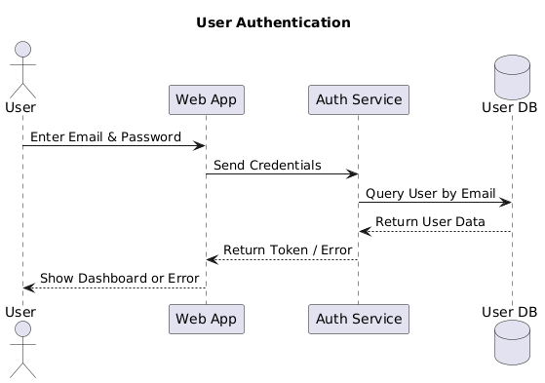
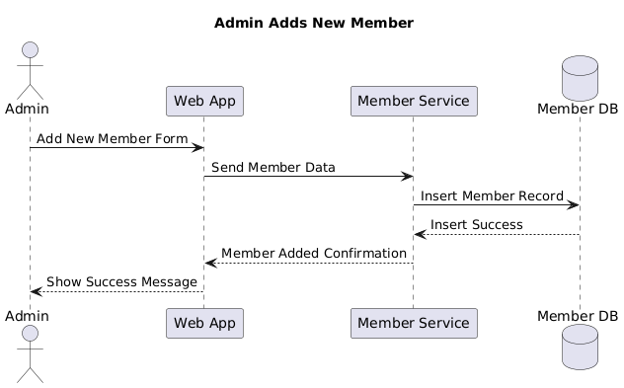
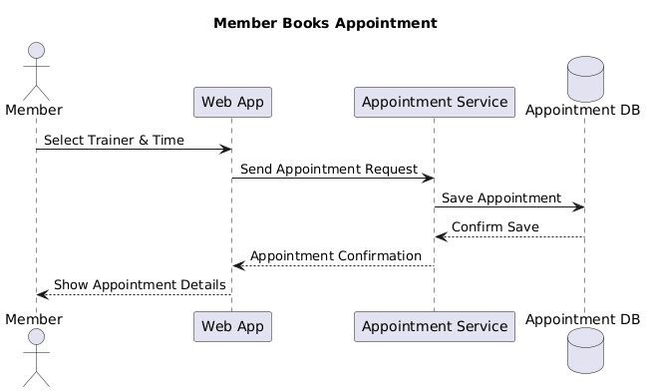
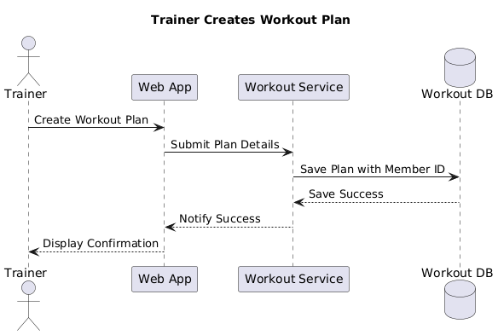
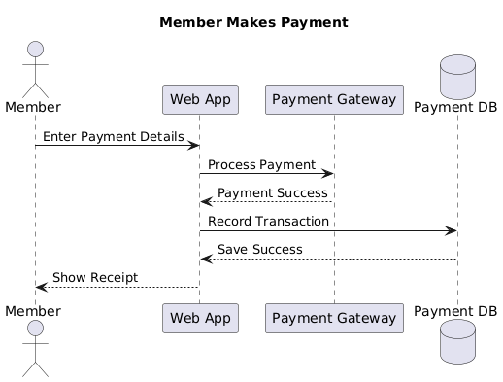

  - Object Model / Logical Model: Class Diagram.

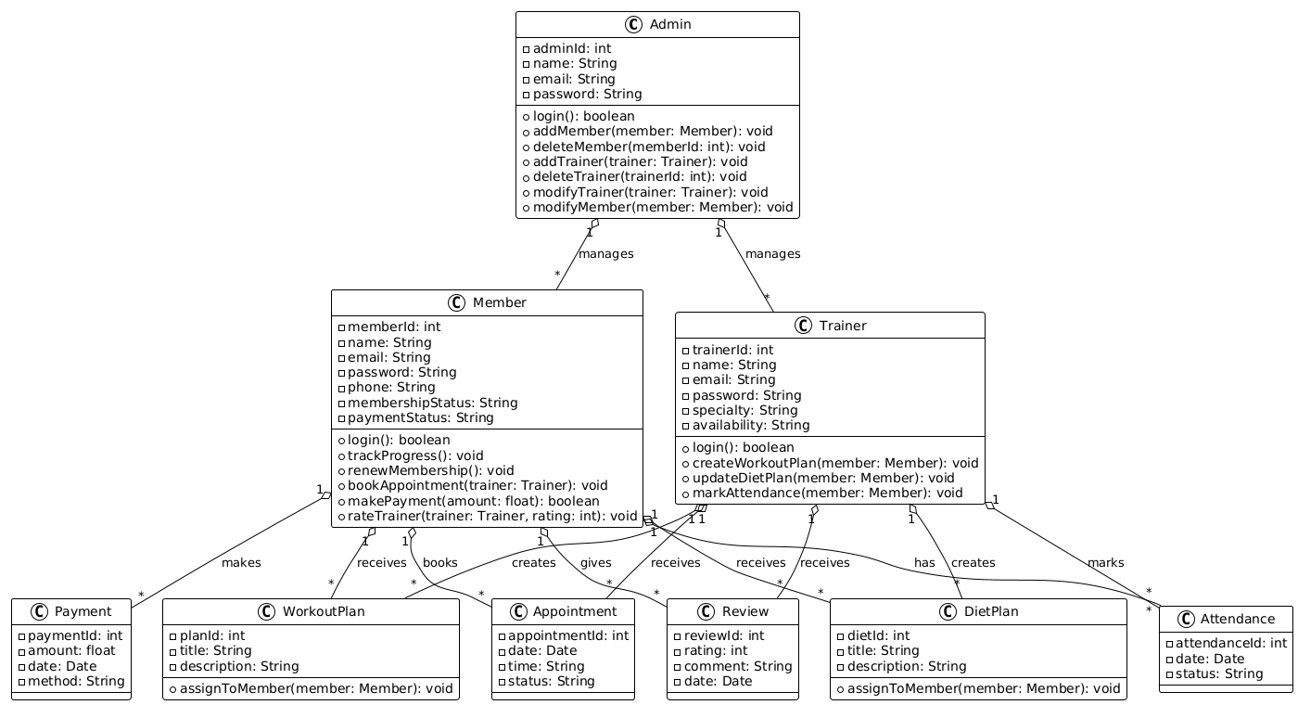
  - Database Model (Database Diagram)

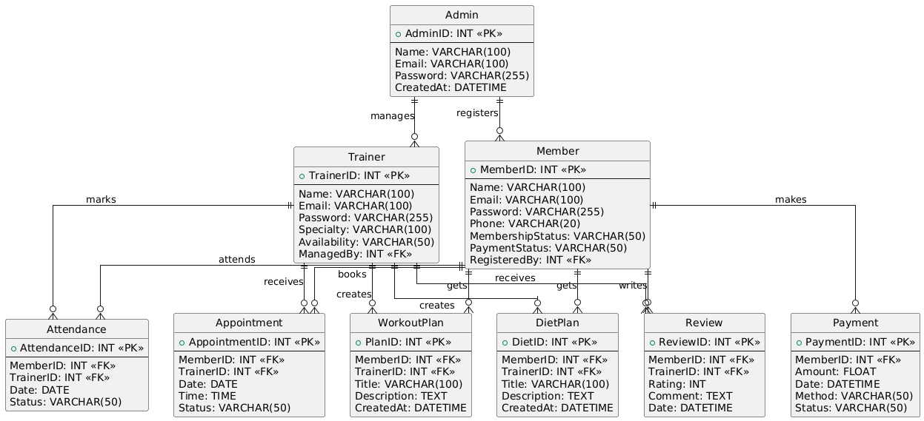

  - Graphical User Interface

